**Instructions**

* Sit quietly for 5 minutes, with your feet flat on the ground and your back against the seat – no slouching, dangling feet, or crossing legs. Limit distractions.
* Arm should be supported on table or armrest with BP cuff at heart level.
* Take three deep and relaxing breaths: inhaling for a count of 3 to 5 seconds and exhaling for a count of 5 to 7 seconds.
* Take your blood pressure and heart rate just one time and record numbers in your log; include the date and time.
  + - If BP seems out of range and you want to repeat, wait 60 seconds before recheck, follow the above instructions
* BP typically at goal range, check BP 1x daily. BP isn’t regularly at goal, take BP 2 different times per day and work with medical team to get BP closer to goal level.
* Instructional video from the American Heart Association:

**\*Ask your doctor: What is my goal blood pressure?**



**My Blood Pressure Log**

My Goal BP: ________

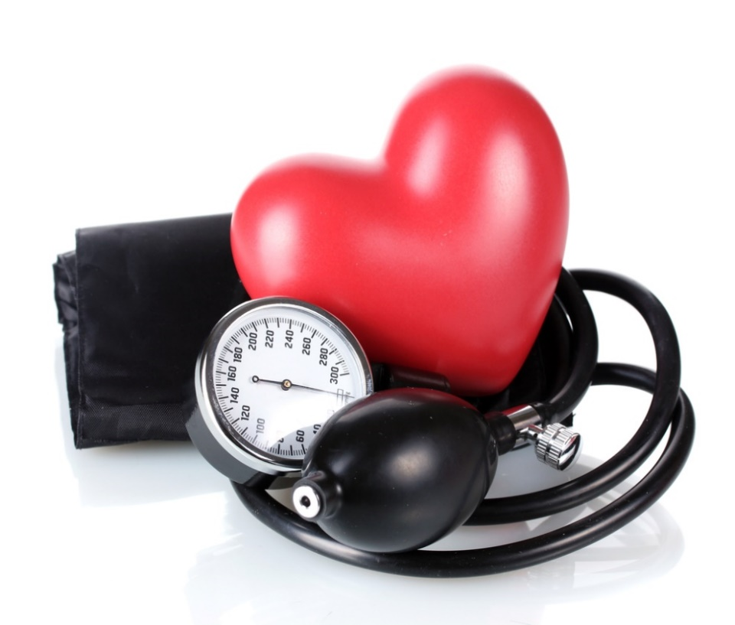

**Instructions:** ______________________________

______________________________

|  |  |  |  |  |
| --- | --- | --- | --- | --- |
| **Date** | **Time** | **BP** | **HR** | **Notes**  **(e.g. stress, tired, calm)** |
|  |  |  |  |  |
|  |  |  |  |  |
|  |  |  |  |  |
|  |  |  |  |  |
|  |  |  |  |  |
|  |  |  |  |  |
|  |  |  |  |  |
|  |  |  |  |  |
|  |  |  |  |  |
|  |  |  |  |  |
|  |  |  |  |  |
|  |  |  |  |  |
|  |  |  |  |  |
|  |  |  |  |  |
|  |  |  |  |  |
|  |  |  |  |  |
|  |  |  |  |  |
|  |  |  |  |  |
|  |  |  |  |  |
|  |  |  |  |  |
| **Date** | **Time** | **BP** | **HR** | **Notes**  **(e.g. stress, tired, calm)** |
|  |  |  |  |  |
|  |  |  |  |  |
|  |  |  |  |  |
|  |  |  |  |  |
|  |  |  |  |  |
|  |  |  |  |  |
|  |  |  |  |  |
|  |  |  |  |  |
|  |  |  |  |  |
|  |  |  |  |  |
|  |  |  |  |  |
|  |  |  |  |  |
|  |  |  |  |  |
|  |  |  |  |  |
|  |  |  |  |  |
|  |  |  |  |  |
|  |  |  |  |  |
|  |  |  |  |  |
|  |  |  |  |  |
|  |  |  |  |  |